Instructions
Directions: | - Fill­ in each box with a synonym (a word you already know that has the same/a similar meaning) or a definition, an image, and a sentence in your own words (or any notes).  - To add the image, click “Insert”, then “image” and then “search” to add an image that will fit. Or you can select the placeholder image and then select “Replace image.”  - The first word has been completed for you.

Vocabulary Word | Synonym or Definition | Image | Sentence (and/or Notes)
orca | a large, black and white sea mammal, which is related to dolphins and eats meat | 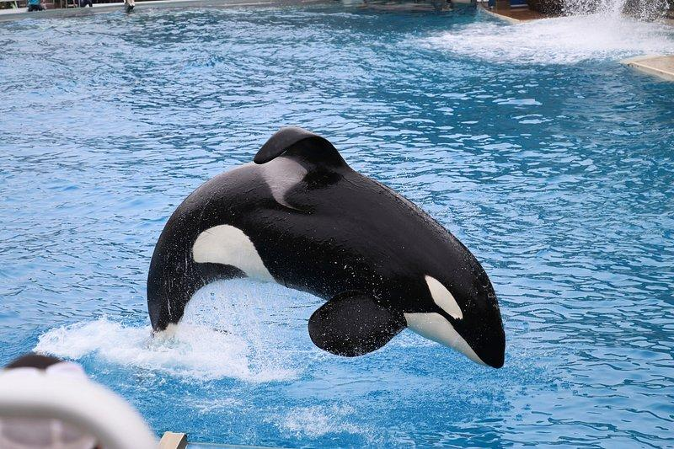 | - Orcas are an intelligent and social species.  - (also killer whale)
captivity | Insert synonym (or definition) |  | Insert a sentence using the word and written in your own words (and/or any additional notes)
dorsal fin | Insert synonym (or definition) |  | Insert a sentence using the word and written in your own words (and/or any additional notes)
OSHA | Insert synonym (or definition) |  | Insert a sentence using the word and written in your own words (and/or any additional notes)
facilities | Insert synonym (or definition) |  | Insert a sentence using the word and written in your own words (and/or any additional notes)
aggressive | Insert synonym (or definition) |  | Insert a sentence using the word and written in your own words (and/or any additional notes)
rehabilitation | Insert synonym (or definition) |  | Insert a sentence using the word and written in your own words (and/or any additional notes)
isolation | Insert synonym (or definition) |  | Insert a sentence using the word and written in your own words (and/or any additional notes)
inhumane | Insert synonym (or definition) |  | Insert a sentence using the word and written in your own words (and/or any additional notes)
unpredictable | Insert synonym (or definition) |  | Insert a sentence using the word and written in your own words (and/or any additional notes)
instigator | Insert synonym (or definition) |  | Insert a sentence using the word and written in your own words (and/or any additional notes)
reinforce | Insert synonym (or definition) |  | Insert a sentence using the word and written in your own words (and/or any additional notes)
regal | Insert synonym (or definition) |  | Insert a sentence using the word and written in your own words (and/or any additional notes)
predator | Insert synonym (or definition) |  | Insert a sentence using the word and written in your own words (and/or any additional notes)
documentary | Insert synonym (or definition) |  | Insert a sentence using the word and written in your own words (and/or any additional notes)
voice­over | Insert synonym (or definition) |  | Insert a sentence using the word and written in your own words (and/or any additional notes)
lifespan | Insert synonym (or definition) |  | Insert a sentence using the word and written in your own words (and/or any additional notes)

